11.87: Use subscripts 1 to denote the copper and 2 to denote the steel. a) From Eq. (11.10), with 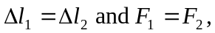
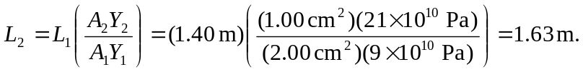
b) For nickel, 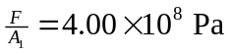and for brass, 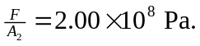c) For nickel, 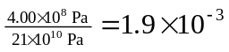and for brass, 